**Zoom Cloud Recording for Remote Labs**

Requirements for Lab Groups:

* At the start of each lab, one member of your lab group must begin a Zoom Cloud Recording and continue recording for the duration of the lab. At the end of each lab session, this group member will be responsible for copy and pasting the sharing information for the Cloud Recording to the Google Doc your lab group is assigned.
  + The person recording does not have to be the same person each time, but make sure that you are ready to record by following the below Zoom Cloud Recording Instructions.

**If you have any problems with any steps, please contact BU IT (see Using Zoom for Remote Labs) or your Graduate Student Teaching Assistant.**

How to Cloud Record on Zoom:

* Follow these simple steps to get ready for Zoom cloud recording!
  1. Make sure you have completed all procedures in [**Using Zoom for Remote Labs**](https://docs.google.com/document/d/1NrBHvJElxtkO7O5a-vZU_6hmzmrlwiA45U05zL8VQrk/edit)
  2. Before starting the lab, hit the “Record” button in the bottom Zoom toolbar:



* 1. Select “Record to the Cloud” and keep recording until you and your group finish the lab.
  2. At the end of the lab, the cloud recording will stop as soon as you end the meeting. Zoom should give you a prompt showing where the Cloud Recording went. If not, you can always go to the settings menu on your Zoom desktop client and navigate to Recording -> Cloud Recording-> Manage my cloud recording.

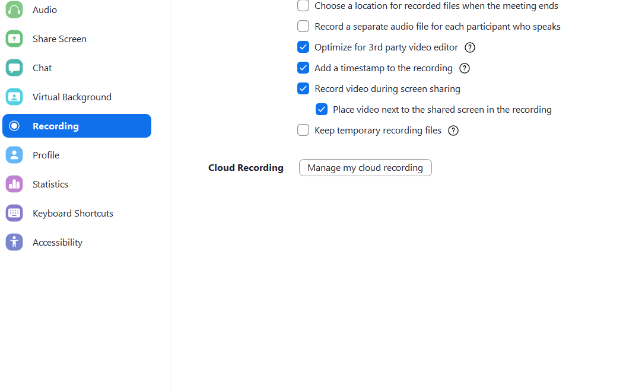

* 1. Navigate to the recording you did for this lab. It should look something like this:

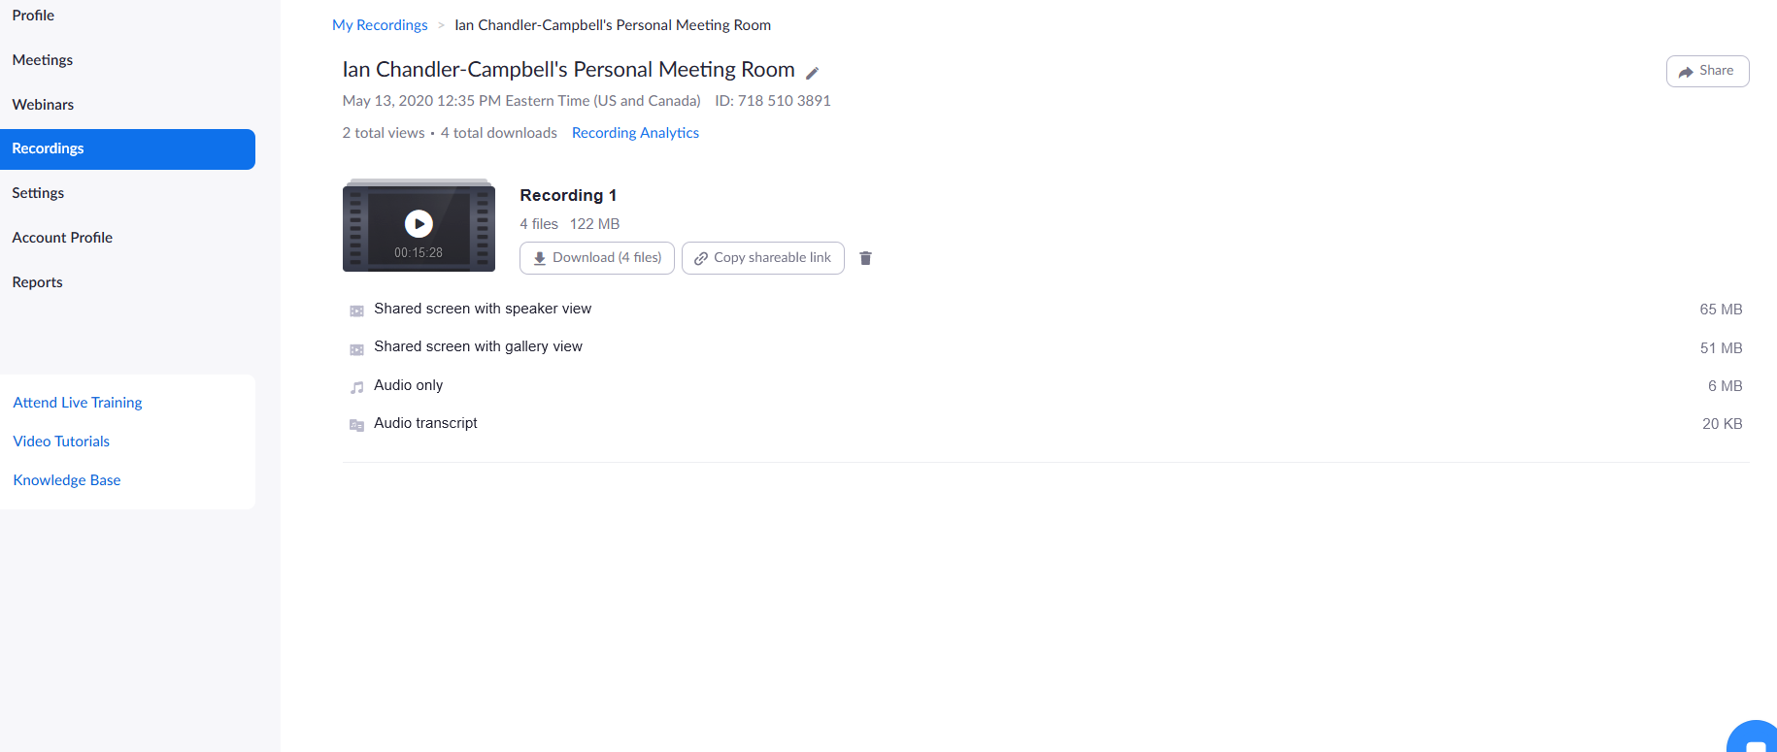

* 1. NOTE: It may take up to an hour for the Cloud Recording to process. If the recording is not done processing when you check it, you can check back later. When you sign in to manage your cloud recordings, make sure to hit the “Sign in with SSO” option and type in “bostonu.zoom.us” to be re-directed to your Kerberos login. Talk to your GST about when you need to share recordings by.
  2. Once your Cloud Recording is processed, hit the “Share” button in the top right corner (see above screenshot).
  3. Select “Share this recording to ON” and “Only authenticated users can view: Signed in users in my account”
  4. Make sure “Viewers can download” is ON
  5. Click “Copy sharing information to clipboard”

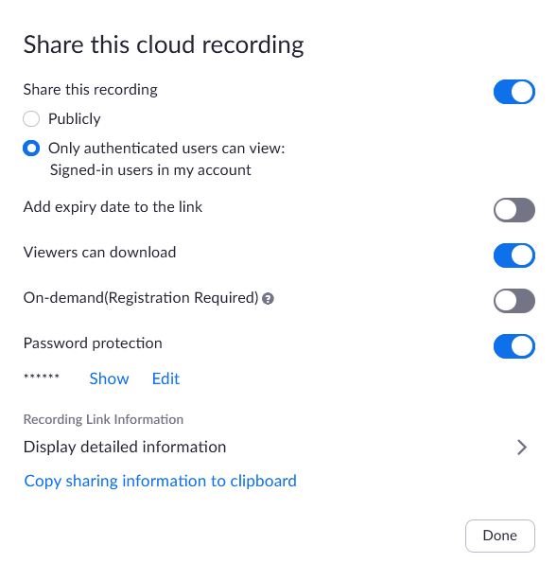

* 1. Paste the sharing information into the Google Doc for your lab group under the appropriate lab.
  2. You’re done!

Tips and Tricks:

* Sharing your entire screen (as opposed to a certain application) records much better (audio and video have zero stutter) and always seems to show people's heads to the side.
* There is an option to include computer sound in your screen share with a small check-box in the screen-share selection pane. Use this if sharing something that has audio.
* Your lab group’s videos will be reviewed by your class’s teaching assistant and educational researchers. We recommend that you hide anything that you don’t want us to see from your computer when screensharing. This can include items on your desktop, non lab-related browser tabs, or any other personal information you might otherwise have visible on your computer screen.
  + Similarly, just like in classes, you may wish to consider if there is anything in the background of your video feed that you do not wish us to see.
* If you are wearing a headset, be mindful that its microphone travels with you. Make sure to take the headset off or mute yourself if you need to briefly leave the lab group (for example, if you need to use the restroom).
  + Similarly, if you are using a mobile phone or laptop, be mindful of what the camera will show if you move locations.